Installing & Configuring
Macromedia ColdFusion MX
Requirements | Install | Configure

Macromedia ColdFusion MX must be installed on the same computer that runs the Web server. The basic requirements for the installation are:
- Copy the data files supplied with the chapter to the default web root.
In this example; C:\inetpub\wwwroot\.
- The Databases subfolder contains the orderdb.mdb Microsoft Access database used in the examples.
- The Images subfolder contains the image files used in the web pages.
- The web pages (*.htm) and ColdFusion script files (*.cfm) used in the examples.
- 256 MB RAM (512 MB recommended)
- 550 MB hard-disk space
- Microsoft Windows 98, ME, NT 4 (Service Pack 6A), 2000 (Service Pack 3), XP, or 2003
- A Web Server (Started). We recommend that you use the IIS Web Server included with Windows 2000 or XP.
- Windows 98 users must use the Personal Web Server included in Microsoft FrontPage. Make sure to download and install the Vulnerability Patch.

Install ColdFusion MX
- Go to www.macromedia.com/downloads/; and click “Try” to download the latest version of Macromedia ColdFusion MX. Register, download, and save the coldfusion-61-win.exe file. Double-click the .exe file to begin. The “Install Anywhere” screen will automatically extract the necessary files and initialize the installation.
- This will open the Macromedia ColdFusion MX screen. Select “English” if necessary, and click OK. 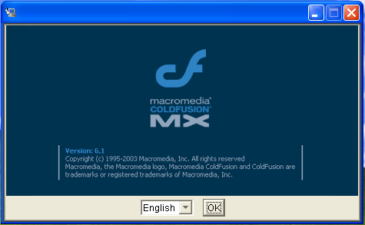
- The Macromedia ColdFusion MX Introduction screen appears, click Next to continue.
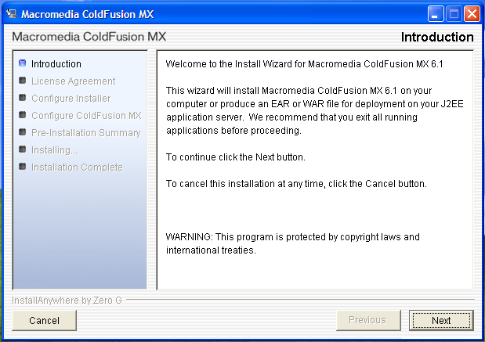
- On the License Agreement screen, select the “I accept the terms of the License Agreement” radio button, and click Next to continue. 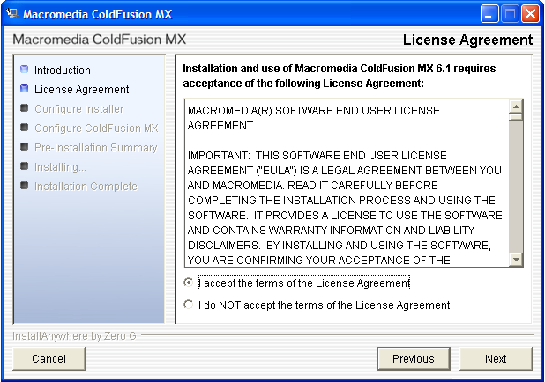
- On the Install Type screen, select the “Install new version of ColdFusion MX” radio button, and enter the appropriate serial information or select the “30-day trial (Enterprise Edition)” checkbox.
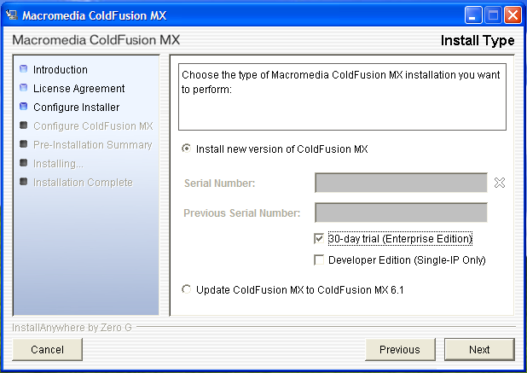
- On the Install Configuration page, accept the default configuration option “Server Configuration”, and click Next.
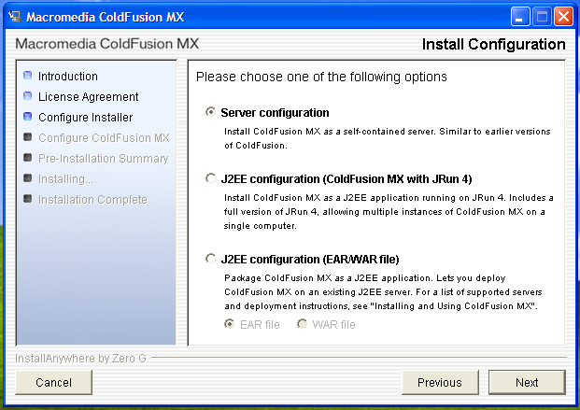
- On the Choose Install Directory screen, accept the default location of “C:\CFusionMX”, and click Next.
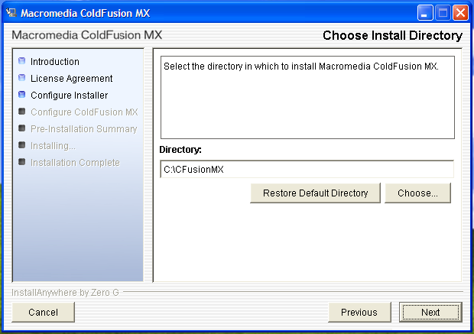
- On the Web Server Selection screen, accept the default of “All IIS websites” and click Next.
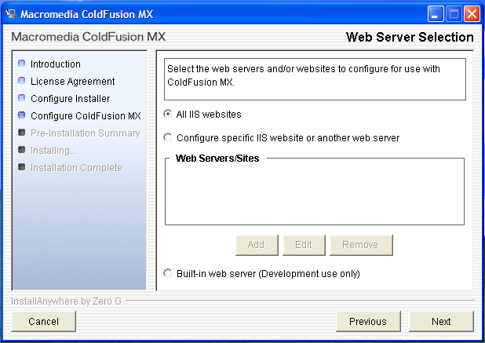
- On the Choose ColdFusion MX Administrator Location screen, accept the default Directory of “C:\Inetpub\wwwroot”, and click Next.
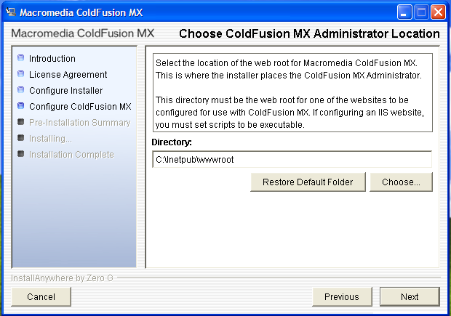
- On the Administrator Password screen, enter a password to use with the Administrator account in ColdFusion. Write this password down in a location where you will remember it. For testing purposes, you can use “adminpw”. Once this has been completed in both password boxes, click Next to continue.
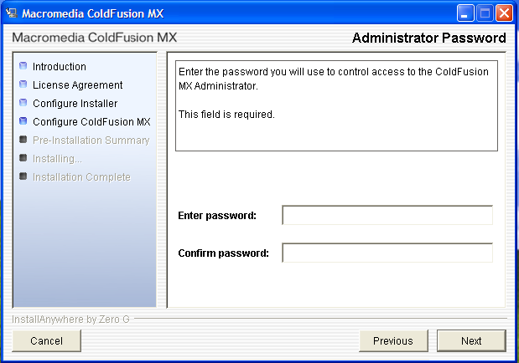
- Review the Installation Confirmation screen information. If all of the information is correct, click the Install button to begin the installation. If any information needs to be changed, click the Previous button to move back to the appropriate screen.
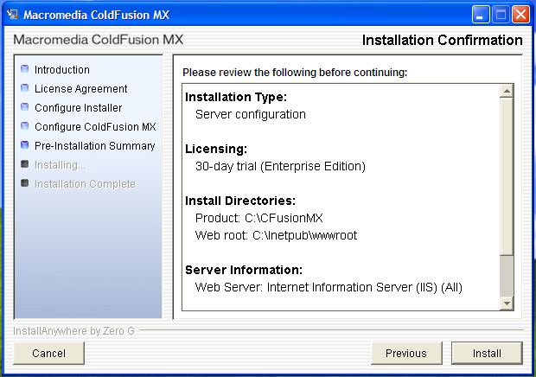

- The installation will take anywhere from 15 minutes to an hour. Multiple Command Prompt windows will open, do not close them. They will close automatically once the appropriate scripts have completed. Once the installation is finished, the Installation Complete screen will appear. Click the Done button to close the Macromedia ColdFusion MX window.
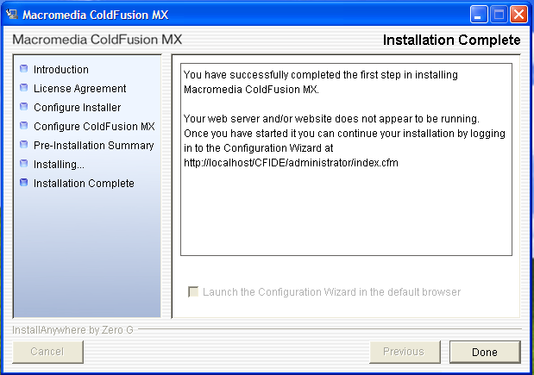
Configure ColdFusion MX
- In Windows XP, on the Start menu, point to All Programs, point to Macromedia, point to Macromedia ColdFusion MX, and click Web Server Configuration Tool. Click Add, and ensure that the Web Server is Internet Information Server (IIS). IIS Web Site should be “Default Web Site”. There should be a check in the checkbox for Configure web server for ColdFusion MX applications. Once your screen matches the figure, click OK to close, and click Yes to restart the server. Click Exit.
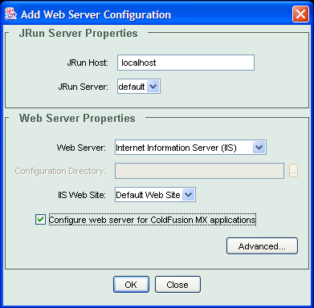
- Open the ColdFusion MX Administrator. In Windows XP, on the Start menu, point to All Programs, point to Macromedia, point to Macromedia ColdFusion MX, and click Adminstrator.
- Enter the Administrator password created in the installation, and click Login.
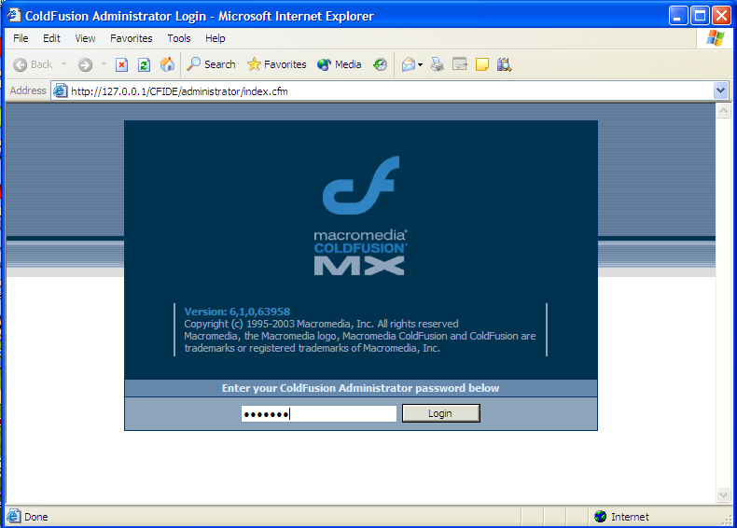
- Enter in an appropriate RDS password, for testing purposes you can use “adminpw”.
- Accept the defaults, if necessary and the ColdFusion Administrator page will open.
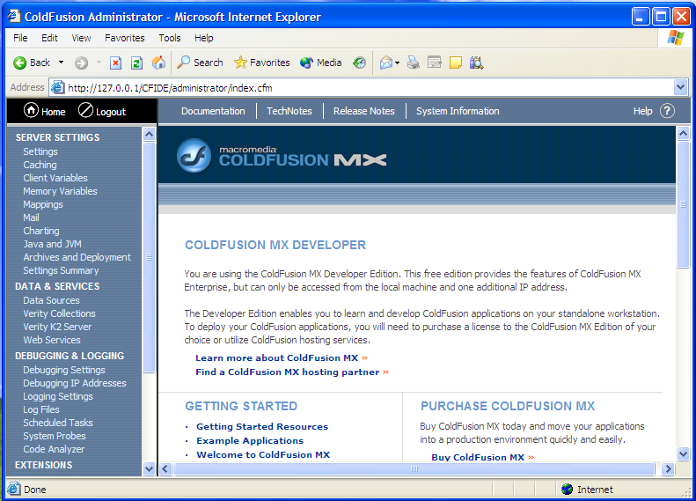

- Under the DATA & SERVICES section of the menu, click Data Sources. On the Data Sources page, enter “robcor” in the Data Source Name text box, and select “Microsoft Access” from the Driver drop-down list. Click Add.
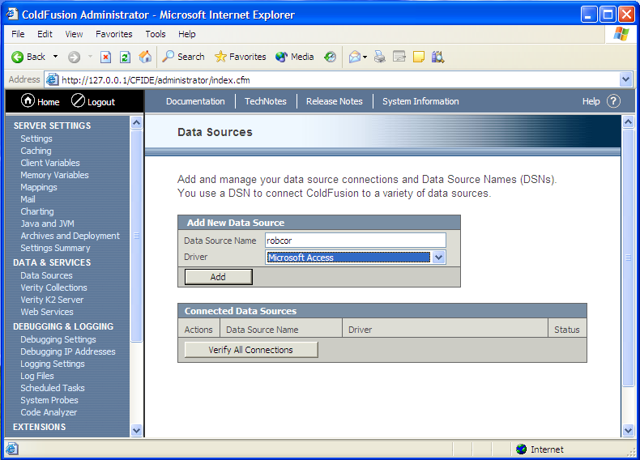

- Enter “robcor” in the CF Data Source name text box. Click the Browse Server button for Database File. Browse to the location (C:\Inetpub\wwwroot\Databases\) of the orderdb.mdb data source. In the ColdFusion Username text box, type “Administrator”. In the ColdFusion Password text box, type “adminpw”. Enter an appropriate description in the Description text box. Click Submit to confirm the database file.
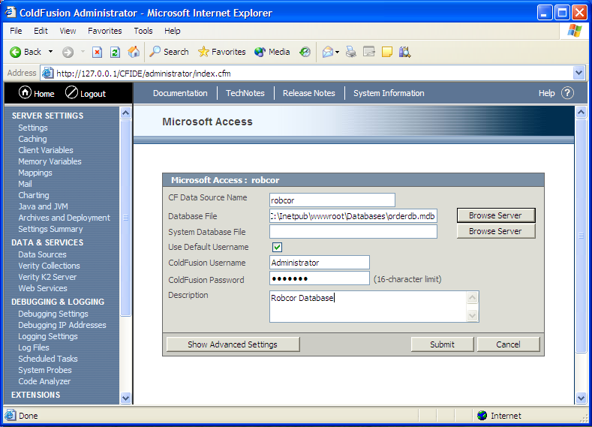

- The robcor database will appear in the Connected Data Sources section. To test the connection, click the “Verify All Connections” button. The Status should be OK.
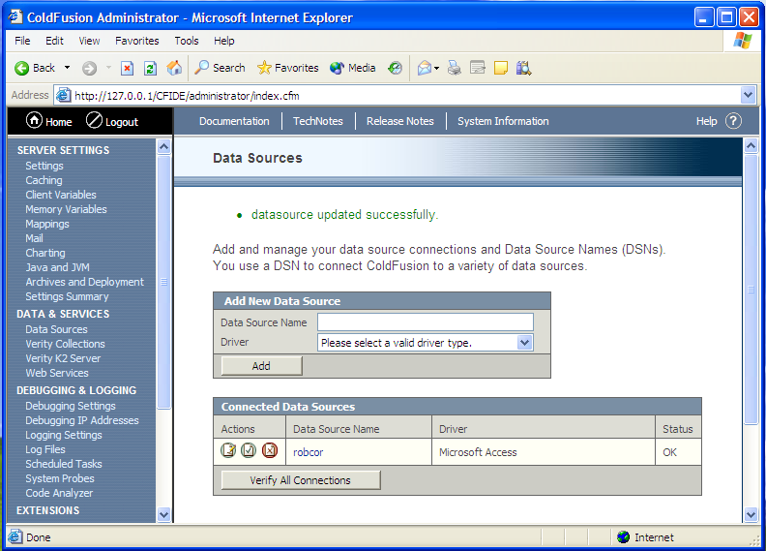

- To test your server, open a Microsoft Internet Explorer browser window. In the Address box, type in your http://localhost/ and press Enter. The Web Database Development screen will appear similar to the figure.
